Expt 10: Development of a Real-Time IoE Stream Analytics and Anomaly Detection System using Node-RED and MQTT
Objectives
- To simulate real-time IoE sensor data using Node-RED.
- To transmit sensor data using the MQTT protocol.
- To perform real-time stream processing and analytics.
- To detect abnormal sensor readings using threshold-based anomaly detection.
- To visualize normal and anomalous data on a dashboard.
Software Required
- Node-RED
- Mosquitto MQTT Broker
- Node-RED Dashboard
Procedure
We will build the flow in stages:
- Create an Inject node to trigger sensor data generation.
- Add a Function node to generate simulated temperature and humidity readings.
- Connect an MQTT Out node to publish the readings.
- Add an MQTT In node to receive the published data.
- Use a Function node to perform stream analytics and detect anomalies.
- Connect Debug nodes to verify the processed data.
- Add dashboard widgets to display sensor readings and anomaly status.
Flow Diagram:
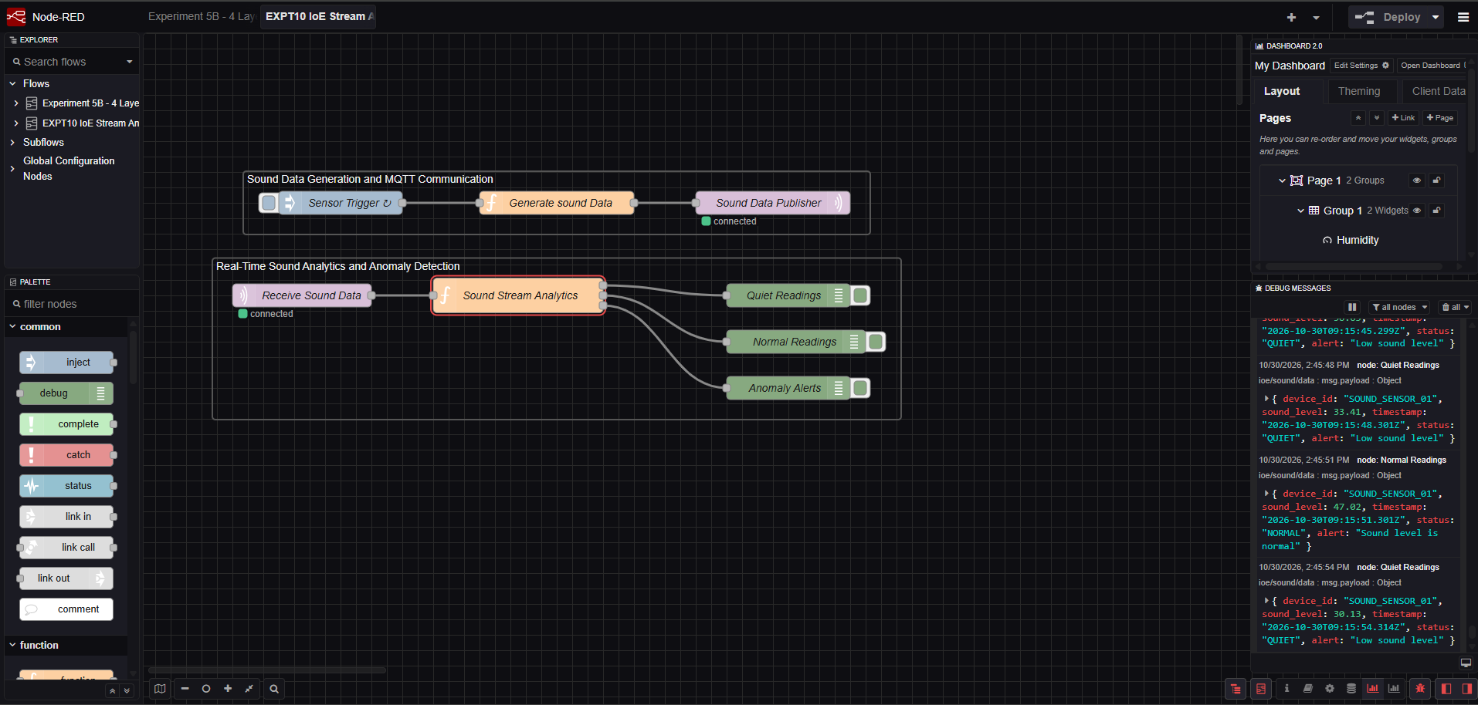
Output Table
S. No. | Simulated Sound Level (dB) | Detected Status | System Output
1 | 32 | QUIET | Low sound level
2 | 55 | NORMAL | Sound level is normal
3 | 68 | NORMAL | Sound level is normal
4 | 85 | ANOMALY | High noise detected
5 | 95 | ANOMALY | High noise detected

Result
Thus, a real-time sound monitoring and anomaly detection system was successfully simulated using Node-RED and MQTT. The system generated sound-level readings processed them using predefined thresholds, and classified them as QUIET, NORMAL, or ANOMALY.
Reflection
This experiment helped me understand MQTT communication, real-time data processing, and threshold-based anomaly detection using Node-RED. I also understood how unusual sound levels can be identified and displayed through a monitoring system.

